Jack Trout
1935-
Wikipedia:
Jack Trout (1935) is among the world's most famous marketing gurus. Over the 40 years of marketing consultancy work, Jack Trout has engaged in hundreds of assignments all over the globe. Among companies whose strategy was influenced by Jack Trout are Microsoft, AT&T, Southwest Airlines, Burger King, Holiday Inn, Iberia, Master Card, Intel, IBM, Procter & Gamble and many others all over the world. He has also acted as
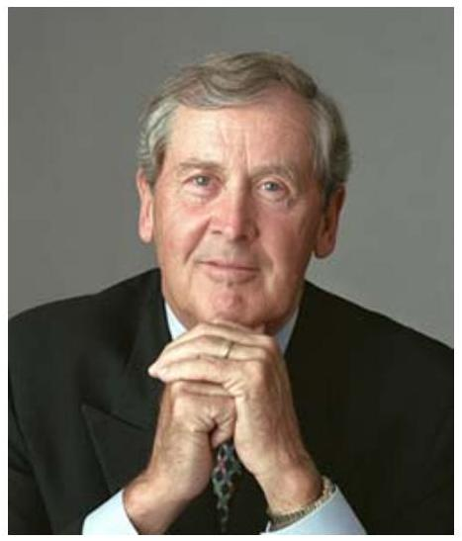
consultant to the US department of State on the "USA" brand.
Notes and Quotes:
Positioning is something (perception) that happens in the minds of the target market. It is the aggregate perception the market has of a particular company, product or service in relation to their perceptions of the competitors in the same category. It will happen whether or not a company's management is proactive, reactive or passive about the on-going process of evolving a position.
No matter how complicated the product, no matter how complicated the needs of the market, it's always better to focus on one word or benefit than two or three or four. For instance, Verizon Wireless stands for "coverage." They could stand for many other things like pricing, or safety, or the selection of phones, or family communications. But, they have focus.
In picking a word, it should be one everyone understands. Don't pick "cheap." Don't pick "quality." Nobody wants to be seen as cheap and every competitor stands for quality.
Applying the name of one product to another is a mistake. The brand will not sell the new product.
Being first can be a differentiating idea. Compare Advil to Nuprin (now dead). What the first-in seeks is to become the generic name for the category. Or, the name that pops into mind when the category is mentioned (laser printer = HP).
Differentiated brands own an attribute. Once an attribute is successfully taken by a competitor, its gone. Colgate "owns" cavity protection in toothpaste. Burger King tried to take "fast" from McDonalds but failed. So it went the other way (slow?) with "Have it your way." The attribute can be a property of the product, of the target buyer, it can be leadership (a social cue) or preference (most people prefer X .)
You don't need a "unique selling proposition." You need a special place in the mind of the buyer. And the mind of the buyer is already full. There is only room for one word or simple concept attached to your product.
Even commodities can be differentiated. Ordinary bananas became better by adding the "Chiquita" label. (Of course, then you have to communicate.) Green Giant's name and image sets a family of vegetables
apart. Cantaloupe producers wanted to differentiate a big cantaloupe, so they invented the name "Crenshaw Melon." Small chickens became "Cornish Game Hens." You can change the name of something, as when the Chinese gooseberry became the "kiwifruit."
A key secret to enduring brands is a constant attention to small changes. The Gillette model is to constantly improve, upgrade, and reinvent. Oral-B toothbrushes hadn't introduced a new toothbrush in 27 years when Gillette acquired it. Gillette put a large team to work studying manual plaque removal and developed a stream of new products, including floss made from a new fiber and its top-of-the-line Advantage toothbrush.

